

Human Parainfluenza Virus Type 3

By: Elda Selimhodžić

**ABSTRACT**

The aim of the paper is to introduce the reader to human parainfluenza virus 3 on the molecular level. Human parainfluenza virus 3 belongs to the Respirovirus genus-group and to the Paramyxoviridae family.

It is a member of the parainfluenza virus family, which causes infection in the upper or lower respiratory tracts of humans. Parainfluenza is made up of four viruses, one of which is HPIV 3. HPIV is extremely contagious. Sneezing is the most common way to transmit them, but it may also be contracted by touching your eyes, nose, or mouth after coming into contact with infected material. In the air, the virus may persist for up to an hour.

The three strains of the human parainfluenza virus 3 are founded for this research. The research paper provides information about the similarity between the strains, the number of mutations, mutations frequency, TT ratio, and the presence of the gaps between the sequences. Results and their explanation are mentioned in the text of the paper below.

**INTRODUCTION**

***Virus species:*** a member of the Respirovirus genus, with Sendai virus as its type species

***Virus strains:*** >EU326526.1 Human parainfluenza virus 3 strain ZHYMgz01, complete genome

>NC_001796.2 Human parainfluenza virus 3, complete genome

>NC_038270.1 Simian Agent 10, complete genome

***Virus size:*** medium size (150 to 250 nm)

***Interesting fact:*** The genome of the human parainfluenza virus type 3 (HPIV3) was found in four baboons in Zambia. HPIV3 antibody was found in 13 baboons and 6 vervet monkeys in two different sites of Zambia. [1]

The first human parainfluenza viruses were found in the late 1950s. However, a great deal of information regarding their molecular structure and function has been gathered just over through the previous decade.[2] Human parainfluenza virus 3, shortly HPIV3, belongs to a group of parainfluenza viruses that usually cause an infection in the upper or lower respiratory tracts of a person's body. Parainfluenza consists of four viruses, which to HPIV 3 also belongs. HPIV is very infectious. They are most usually spread by sneezing, but they can also be contracted by coming into contact with contaminated material and then touching your eyes, nose, or mouth. The virus may survive for up to an hour in the air.[3]

It is an enclosed, single-stranded, negative-experience virus that preferentially infects lung epithelial cells of the airway and belongs to the Paramyxoviridae family. Airborne HPIV-three contamination now no longer best reasons infection states including pneumonia and bronchiolitis in babies, however, it additionally reasons substantial morbidity in immunocompromised adults. [4]

In the study „Human parainfluenza virus type 3 (HPIV3) induces production of IFNγ and RANTES in human nasal epithelial cells (HNECs)“ it is found that HPIV3 successfully infects upper airway epithelial cells, and infection is linked with IFN- induction and RANTES production. [5]

This virus is the second most prevalent cause of severe respiratory tract illness in babies and children, behind human respiratory syncytial virus (RSV). By the age of two, around 60% of children have been infected with PIV3, and bronchiolitis and/or pneumonia can develop in 10% to 30% of those infected, particularly those who are immunocompromised or have chronic respiratory or cardiac problems. PIV3 infects and causes sickness in the respiratory system but does not extend much beyond that. Combined innate and adaptive immune responses help clear PIV3 infection and create resistance to recurrent reinfection.[6] In the United States, approximately 18,000 babies, and children are hospitalized each year as a result of lower respiratory infections caused by human parainfluenza virus-3. This virus generates yearly spring and summer epidemics in North America and Europe, and it is fairly endemic, particularly in immunocompromised and chronically sick people. [7]

Virus-specific T-cell therapy has been shown to be effective in the treatment or prevention of viral infections in people with weakened immune systems, but it needs the identification of T-cell antigens on targeted viruses.

HPIV3-specific T cells, which are primarily CD4+ T cells with Th1 activity, may be generated from healthy donors utilizing a quick ex vivo technique. HPIV3 epitopes can also be successfully targeted with numerous other viral epitopes in the development of six-virus T cells without compromising HPIV3 specificity. In immune-compromised individuals, these medicines may be therapeutically effective in combating HPIV3 infections by adoptive T-cell therapy. [8]

Infections with human parainfluenza virus-3 are most common in the spring and early summer months of each year. Human parainfluenza virus-3 infections, on the other hand, can occur at any time of year, particularly when human parainfluenza virus-1 and human parainfluenza virus-2 are not in season. [9]

**MATERIALS AND METHODS**

Programs used for researching: NCBI ( National Center for Biotechnology Information) & Clustal Omega (Multiple Sequence Alignment program). Excel was used for tables and graphs.

Materials: Genome

***>EU326526.1 Human parainfluenza virus 3 strain ZHYMgz01, complete genome***

***>NC_001796.2 Human parainfluenza virus 3, complete genome***

***>NC_038270.1 Simian Agent 10, complete genome***

Methods:

* Genomic Sequence Search

1. Go to NCBI, select Genome, and enter your assortment.

2. Choose „Genome Assembly and Annotation Report“ and, in order to get the sequence, click on the replicons.

3. To get your sequence, you can click on FASTA and copy it or choose the option „ Send to“ ---> Format FASTA ---> Create the file

* Protein Coding Gene Search

1. Choose the organism name
2. Click on the „ Protein“ number in the „ Replicon info“ table
3. In order to have it, download the table of protein gene in .csv file

* Multiple Sequence Alignment

1. Go to Clustal Omega, select DNA as a sequence type
2. Insert your sequences
3. Select „ClustalW“ as output
4. In „More options“ select order to be input ---> press Submit
5. When the document is ready, press „ Download Alignment File“

**RESULTS**

*Sequence Length:* **15 462**

*Coding Sequence length:* **14 583**

*Non- coding Sequence length:* **924**

***Similarities:***

Since there are presented only 2 strains, plus 1 reference strain, the similarities are as the following:

Strain 2 is 94,76% similar to strain 1, while strain 3 is 95,99% similar to strain 1.

*Coding sequence similarities:*

Regarding the comparison of coding sequence similarity, Strain 2 is 95,06% similar to Strain 1. With no huge difference, Strain 3 is 96,28% similar to Strain 1.

*Non-coding sequence similarities:*

Regarding the comparison of non-coding sequence similarity, Strain 2 is 90% similar to Strain 1. A similar percentage is between Strain 3 and Strain 1- 91,34%.

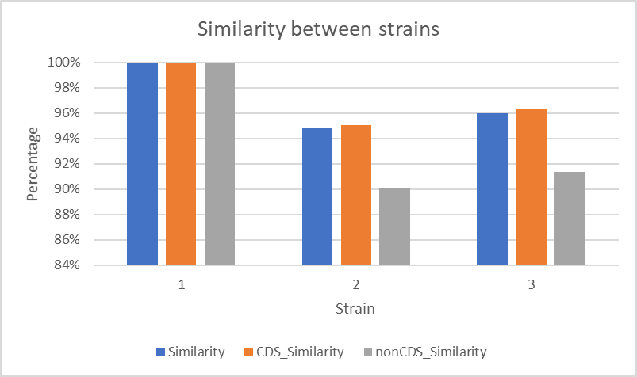

***Mutations:***

Strain 2 accumulated 810 mutations while Strain 3 accumulated 620 mutations when compared to Strain 1.

*Coding mutations:*

When coding sequence mutations were compared to strain 1, strain 2 accumulated 718 mutations, and strain 3 accumulated 540 mutations.

*Non-coding mutations:*

Comparing the non-coding mutations, strain 2 accumulated 92 mutations compared to strain 1 while strain 3 accumulated 80 mutations.

***Mutation frequency:***

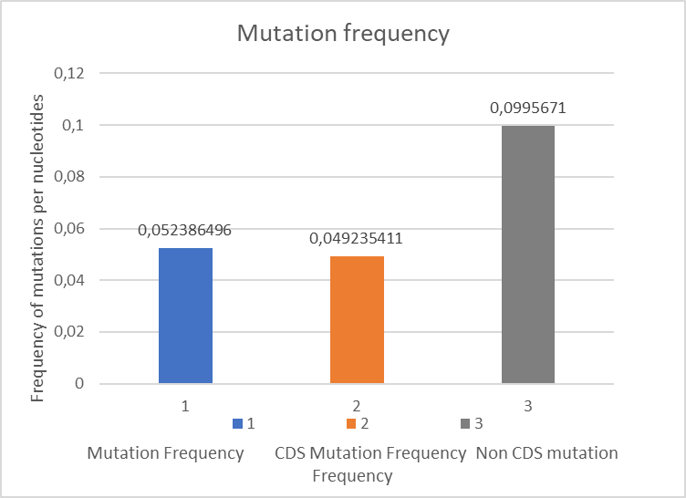

Overall mutation frequency: 810/15 462= **0.052** (810- number of mutations in sequences; 15 462- the whole sequence long)

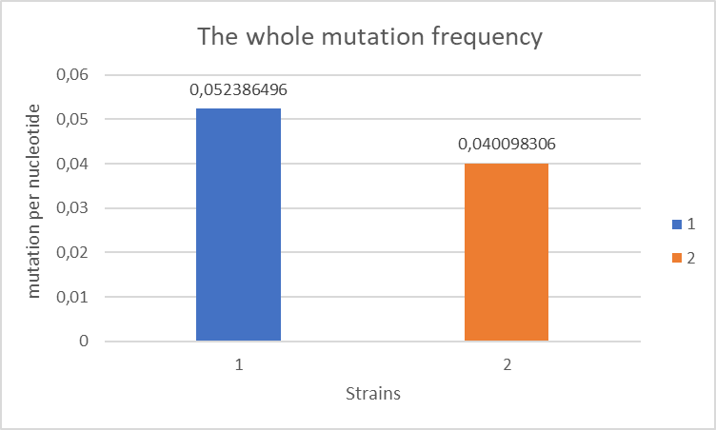

This result shows that the overall mutation frequency is 0.052 mutations per nucleotide.

Coding Sequence frequency: 718/ 14 583= **0.049** ( 718- number of mutations in coding sequence; 14 583- the length of the coding sequence)

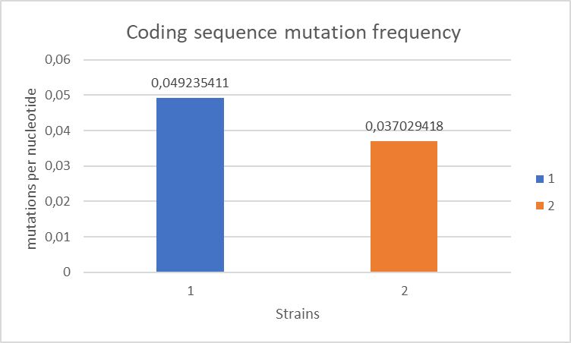

The coding sequence mutation frequency is 0.049 mutations per nucleotide.

Non- coding Sequence frequency: 92/ 924= **0.099** ( 92- number of mutations in non-coding sequence; 924- the length of the non-coding sequence)

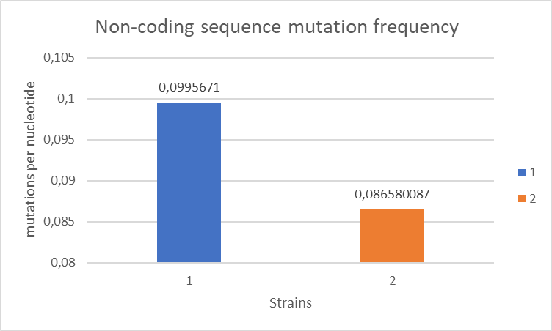

The non-coding sequence mutation frequency is 0.099 mutations per nucleotide.

***Gaps-*** no gaps

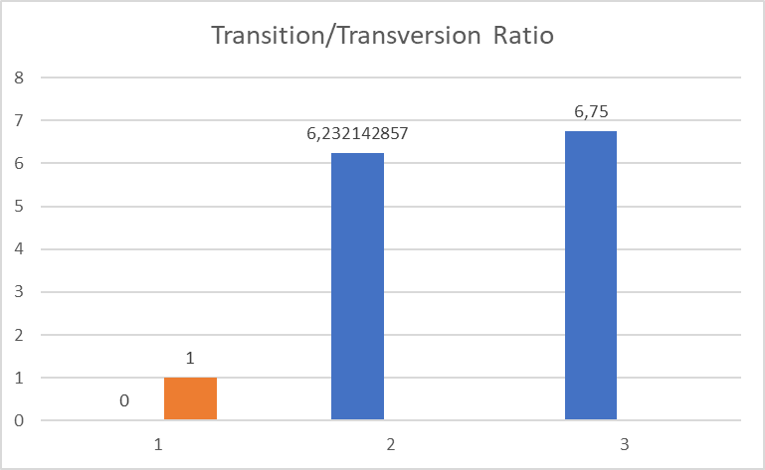**TT RATIO-** Strain 2 & Strain 3 ratio ---> 6,23: 6,75 (1:1)

Coding Sequence Transition/ Transversion ratio ---> 6,32 : 7,059

Non-coding Sequence Transition/ Transversion ratio ---> 5,57 : 5,15

**DISCUSSION**

A strain is a genetically different viral lineage that may be distinguished from another strain by one or more mutations. Strains can be physiologically (functionally) distinct from one another. If two strains generated different responses from the human immune system or had different transmission properties, they would be physiologically distinct. [10]

The results of this article show that there is a significant degree of similarity between strains in these sequences. As a primary reason, when there is an excess of similarity, the simplest explanation is that the two sequences did not arise independently. In various ways, they descended from a single ancestor. As a result, common ancestry accounts for the additional connection. [11]

If these sequences are actually homologs, it is likely that when they separated from a common ancestor, one had a base removed and the other had a base added.

The absence of gaps can mean, or it might suggest that the aligned sequences have no multiple matching sequences in that area, or that the sequencing data isn't good enough quality for the program to place the aligned sequences together convincingly.[12]

The mutation frequency is higher in non-coding sequences than in coding sequences, due to a lack of positive selection, pseudogene sequences tend to acquire mutations faster than coding regions. Many uncommon illnesses may be caused by non-coding loss-of-function mutations. [13]

Predicting the ratio of transitions to transversions (T:T ratio) for a set of aligned nucleotide sequences is essential because it gives insight into the process of molecular evolution and may be used to further describe the evolutionary process for the sequences in question. [14]

**CONCLUSION**

To complete the research paper, it is important to notice that there were 3 strains of human parainfluenza virus 3 found, where the first one presents reference strain. The research paper details the similarity of the strains, the number of mutations, the frequency of mutations, the TT ratio, and the presence of gaps between the sequences. The paper's results and explanations are included in the text below. The similarities between Strain 2 is 94,76% similar to strain 1, while strain 3 is 95,99% similar to strain 1.

Regarding the comparison of coding sequence similarity, Strain 2 is 95,06% similar to Strain 1. With no huge difference, Strain 3 is 96,28% similar to Strain 1.

Regarding the comparison of non-coding sequence similarity, Strain 2 is 90% similar to Strain 1. A similar percentage is between Strain 3 and Strain 1- 91,34%.

When it comes to the mutations, Strain 2 accumulated 810 mutations while Strain 3 accumulated 620 mutations when compared to Strain 1.

When coding sequence mutations were compared to strain 1, strain 2 accumulated 718 mutations, and strain 3 accumulated 540 mutations.

Comparing the non-coding mutations, strain 2 accumulated 92 mutations compared to strain 1 while strain 3 accumulated 80 mutations.

It can be noticed that the mutation frequency is higher in non-coding sequences than in coding sequences, due to a lack of positive selection.

The absence of gaps might suggest that the aligned sequences have no multiple matching sequences in that area, or that the sequencing data isn't good enough quality for the program to place the aligned sequences together convincingly. [15]

**REFERENCES**

1. Sasaki et al., “Human Parainfluenza Virus Type 3 in Wild Nonhuman Primates, Zambia - Volume 19, Number 9—September 2013 - Emerging Infectious Diseases Journal - CDC.”

<https://wwwnc.cdc.gov/eid/article/19/9/12-1404_article>

1. “Human Parainfluenza Virus Infections, Symptoms, Diagnosis and Treatment.”

<https://healthjade.com/parainfluenza/>

1. “Parainfluenza Virus Type 3 - NORD (National Organization for Rare Disorders).”

<https://rarediseases.org/gard-rare-disease/parainfluenza-virus-type-3/>

1. „Role of Nucleolin in Human Parainfluenza Virus Type 3 Infection of Human Lung Epithelial Cells | Journal of Virology.”

<https://journals.asm.org/doi/full/10.1128/JVI.78.15.8146-8158.2004>

1. “Human Parainfluenza Virus Type 3 (HPIV3) Induces Production of IFNγ and RANTES in Human Nasal Epithelial Cells (HNECs) | Journal of Inflammation | Full Text.”

<https://journal-inflammation.biomedcentral.com/articles/10.1186/s12950-015-0054-7>

1. Zhang et al., “Infection of Ciliated Cells by Human Parainfluenza Virus Type 3 in an In Vitro Model of Human Airway Epithelium.”

<https://journals.asm.org/doi/full/10.1128/JVI.79.2.1113-1124.2005>

1. “Human Parainfluenza Virus Infections, Symptoms, Diagnosis and Treatment.”

<https://healthjade.com/parainfluenza/>

1. “Human Parainfluenza Virus-3 Can Be Targeted by Rapidly Ex Vivo Expanded T Lymphocytes - Cytotherapy.”

<https://www.isct-cytotherapy.org/article/S1465-3249(16)30499-6/fulltext>

1. “Human Parainfluenza Virus Infections, Symptoms, Diagnosis and Treatment.”

<https://healthjade.com/parainfluenza/>

1. “Are There Different Strains of the SARS-CoV-2 Virus Circulating? - Coronavirus: The Science Explained - UKRI.”

<https://coronavirusexplained.ukri.org/en/article/cad0013/>

1. “An Introduction to Sequence Similarity (‘Homology’) Searching.”

<https://www.ncbi.nlm.nih.gov/pmc/articles/PMC3820096/>

1. “(1) What Do Gaps in Multiple Sequence Alignment Mean? - Quora.”

<https://www.quora.com/What-do-gaps-in-multiple-sequence-alignment-mean>

1. Zappala and Montgomery, “Non-Coding Loss-of-Function Variation in Human Genomes.”

<https://www.ncbi.nlm.nih.gov/pmc/articles/PMC5499665/>

1. Kristina Strandberg and Salter, “A Comparison of Methods for Estimating the Transition.”<https://pubmed.ncbi.nlm.nih.gov/15223032/>

1. Sasaki et al., “Human Parainfluenza Virus Type 3 in Wild Nonhuman Primates, Zambia - Volume 19, Number 9—September 2013 - Emerging Infectious Diseases Journal - CDC.”
2. “Human Parainfluenza Virus Infections, Symptoms, Diagnosis and Treatment.”
3. “Parainfluenza Virus Type 3 - NORD (National Organization for Rare Disorders).”
4. “Role of Nucleolin in Human Parainfluenza Virus Type 3 Infection of Human Lung Epithelial Cells | Journal of Virology.”
5. “Human Parainfluenza Virus Type 3 (HPIV3) Induces Production of IFNγ and RANTES in Human Nasal Epithelial Cells (HNECs) | Journal of Inflammation | Full Text.”
6. Zhang et al., “Infection of Ciliated Cells by Human Parainfluenza Virus Type 3 in an In Vitro Model of Human Airway Epithelium.”
7. “Human Parainfluenza Virus Infections, Symptoms, Diagnosis and Treatment.”
8. “Human Parainfluenza Virus-3 Can Be Targeted by Rapidly Ex Vivo Expanded T Lymphocytes - Cytotherapy.”
9. “Human Parainfluenza Virus Infections, Symptoms, Diagnosis and Treatment.”
10. “Are There Different Strains of the SARS-CoV-2 Virus Circulating? - Coronavirus: The Science Explained - UKRI.”
11. “An Introduction to Sequence Similarity (‘Homology’) Searching.”
12. “(1) What Do Gaps in Multiple Sequence Alignment Mean? - Quora.”
13. Zappala and Montgomery, “Non-Coding Loss-of-Function Variation in Human Genomes.”
14. Kristina Strandberg and Salter, “A Comparison of Methods for Estimating the Transition.”
15. “(1) What Do Gaps in Multiple Sequence Alignment Mean? - Quora.”